1. 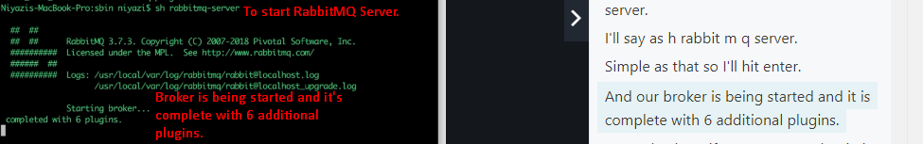
2. See, the management plugin is also enabled so we can see the management UI.
3. NOTE Completed